Store Books ETL and Data Warehouse Project

Project Overview:
This project aims to transform the existing Store Books Sales database into a robust data warehouse, enabling advanced analytics and reporting capabilities. The project involves the use of Extract, Transform, Load (ETL) processes to migrate and transform data, and the implementation of SQL Server Analysis Services (SSAS) to create a cube for in-depth data analysis.

Source Database Overview:

Database Information:
- Database Type:
  - Relational Database (Microsoft SQL Server).
- Technology Stack:
  - Microsoft SQL Server (2019)
  - SQL Server Management Studio (SSMS) for database management.

Data Structure:

Tables and Entities:
- author Table:
  - Purpose: Stores information about book authors.
  - Fields:
    - author_id: Unique identifier for the author.
    - author_name: Name of the author.
  - Constraints:
    - Primary Key: author_id
- publisher Table:
  - Purpose: Stores information about book publishers.
  - Fields:
    - publisher_id: Unique identifier for the publisher.
    - publisher_name: Name of the publisher.
  - Constraints:
    - Primary Key: publisher_id
- book_language Table:
  - Purpose: Stores information about book languages.
  - Fields:
    - language_id: Unique identifier for the language.
    - language_code: Code representing the language.
    - language_name: Name of the language.
  - Constraints:
    - Primary Key: language_id
- book Table:
  - Purpose: Stores information about books.
  - Fields:
    - book_id: Unique identifier for the book.
    - title: Title of the book.
    - isbn13: ISBN-13 code of the book.
    - language_id: Foreign key referencing book_language table.
    - num_pages: Number of pages in the book.
    - publication_date: Date when the book was published.
    - publisher_id: Foreign key referencing publisher table.
  - Constraints:
    - Primary Key: book_id
    - Foreign Keys: language_id, publisher_id
- book_author Table:
  - Purpose: Represents the many-to-many relationship between books and authors.
  - Fields:
    - book_id: Foreign key referencing book table.
    - author_id: Foreign key referencing author table.
  - Constraints:
    - Primary Key: Composite key (book_id, author_id)
    - Foreign Keys: book_id, author_id

Primary Entities and Relationships:
- The data structure in the Store_books database comprises key tables, each representing a specific entity such as authors, publishers, book languages, books, and their relationships.
- Author-Book Relationship:
  - The book_author table establishes a many-to-many relationship between books and authors.
- Book-Publisher Relationship:
  - The book table includes a foreign key (publisher_id) referencing the publisher table, establishing a relationship between books and publishers.

Data Extraction Methods:
- Extraction Tools:
  - SQL Server Integration Services (SSIS) for data extraction.

Sample Data:

Source Database Schema:
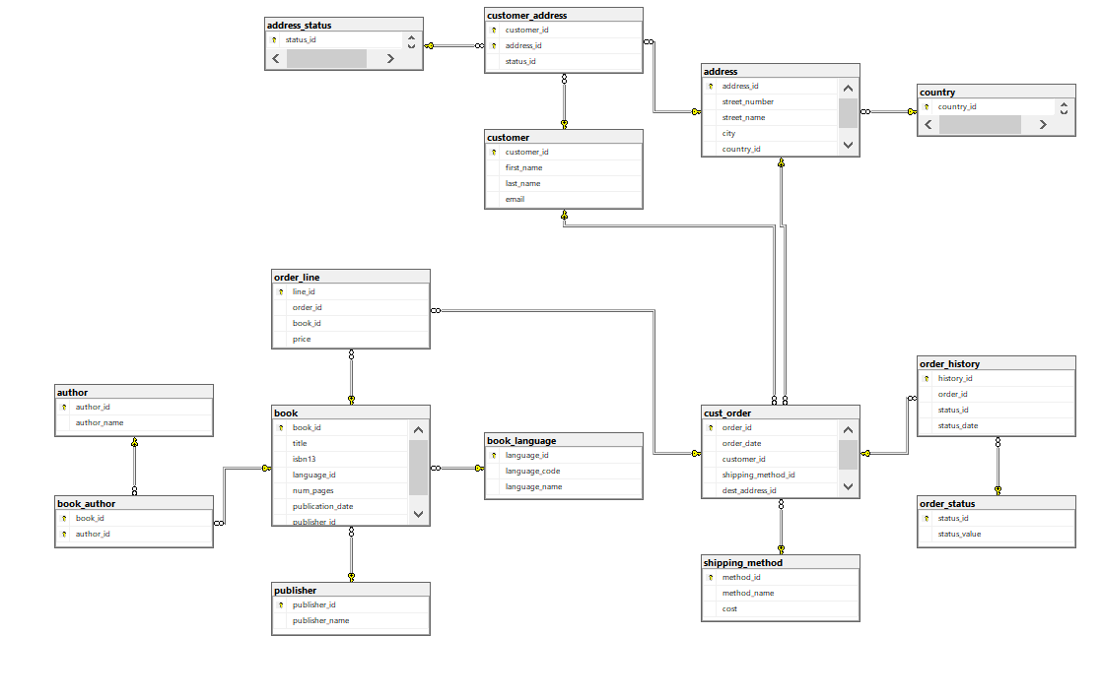

The above image provides an overview of the schema structure in the Store Books Sales source database, illustrating tables, relationships, and key entities.
Understanding the source database is crucial for designing effective ETL processes and creating a well-structured data warehouse. The information gathered from the source database informs decisions about data transformations, mappings, and optimizations during the ETL process.

Data Warehouse

Data Modeling:
- Entity-Relationship Diagram (ERD):
- 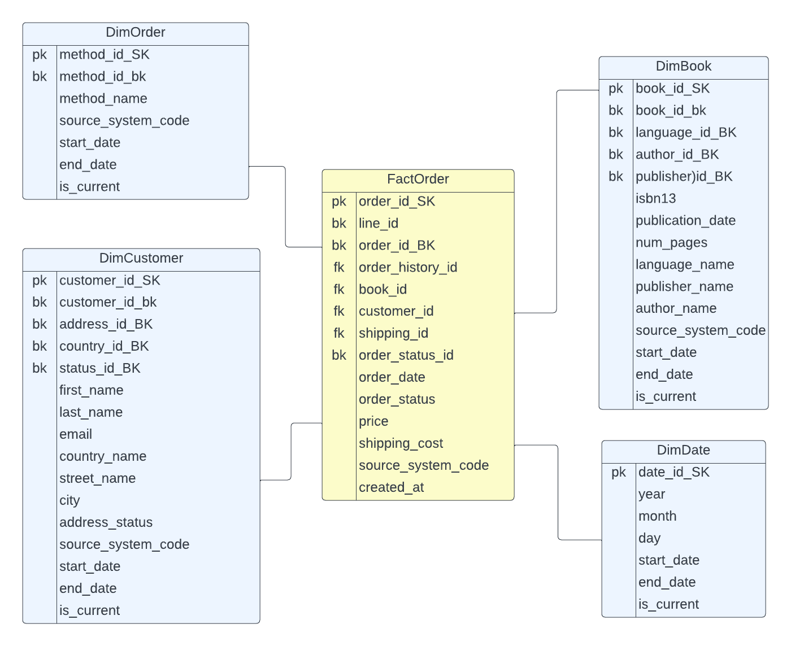

Schema and Tables:

Tables Overview:

DimOrder Table:
- Location: Top left corner of the image.
- Fields:
  - method_id_SK (Primary Key)
  - method_id_bk (Business Key)
  - method_name
  - source_system_code
  - start_date
  - end_date
  - is_current

FactOrder Table:
- Location: Center of the image.
- Fields:
  - order_id_SK (Primary Key)
  - line_id (Business Key)
  - order_history_id (Foreign Key)
  - book_id (Foreign Key)
  - customer_id (Foreign Key)
  - shipping_method_id (Foreign Key)
  - order_status_id (Business Key)
  - order_status
  - price
  - shipping_cost
  - source_system_code
  - created_at
line_id
order_history_id
book_id
customer_id
o shipping_method_id
order_status_id
order_status
price
shipping_cost
source_system_code
created_at

DimBook Table:
- Location: Top right corner.
- Fields:
  - book_id_SK (Primary Key)
  - book_id_BK (Business Key)
  - language_id_BK (Business Key)
  - author_id_BK (Business Key)
  - publisher_id_BK (Business Key)
  - isbn13
  - publication_date
  - num_pages
  - language_name
  - publisher_name
  - author_name
  - source_system_code
  - start_date
  - end_date
  - is_current

DimCustomer Table:
- Location: Bottom left corner.

- Fields:
  - customer_id_SK (Primary Key)
  - customer_id_BK (Business Key)
  - address_id_BK (Business Key)
  - country_id_BK (Business Key)
  - status_id_BK (Business Key)
  - first_name
  - last_name
  - email
  - country_name
  - street_name
  - city
  - address_status
  - source_system_code
  - start_date
  - end_date
  - is_current
line_id
order_history_id
book_id
customer_id
date_Id_SK
order_status_id
order_status
price
shipping_cost
source_system_code
created_at

DimDate Table:
- Location: Bottom right corner.
- Fields:
  - date_Id_SK (Primary Key)
  - year
  - month
  - day
  - start_date
  - end_date
  - is_current

Schema Architecture:
- Each table is connected to the FactOrder table via foreign keys, forming a star schema.
- The FactOrder table is positioned at the center, surrounded by dimension tables (DimOrder, DimBook, DimCustomer, DimDate).
- This star schema architecture facilitates efficient querying and data analysis, a common practice in Data Warehousing.

Note:
Prepare project report after practice
🔹 Extracting Data for FactOrder
To populate FactOrder, we need data from multiple tables:

FactOrder Column | Source Table | Mapped Column
line_id | order_line | line_id
order_history_id | order_history | history_id
book_id | DimBook | book_id_SK
customer_id | DimCustomer | customer_id_SK
date_Id_SK | DimDate | date_id_SK
order_status_id | order_status | status_id
order_status | order_status | status_value
price | order_line | price
shipping_cost | shipping_method | cost
source_system_code | Static Value | 'gravity_books Database'
created_at | cust_order | order_date

